Experiment 16: Cloning of a Virtual Machine and Testing the Cloned VM

Aim
To create a clone of an existing virtual machine using VMware Workstation and test the cloned virtual machine by loading and verifying its configuration.

Procedure
1. Open VMware Workstation and select the Ubuntu1 virtual machine.
2. Open the Clone Virtual Machine Wizard from the virtual machine options.
3. Enter a suitable name and storage location for the cloned virtual machine.
4. Complete the cloning process by selecting Finish.
5. Open the newly created Clone of Ubuntu1 virtual machine.
6. Verify that the cloned VM has the same hardware configuration as the original VM.
7. Power on the cloned VM to test that it can be loaded successfully.

Observation
The virtual machine was successfully cloned in VMware Workstation. The cloned VM named 'Clone of Ubuntu1' was created successfully. The displayed configuration was 2 GB memory, 1 processor and 15 GB hard disk, matching the configured virtual machine.

Screenshots / Evidence
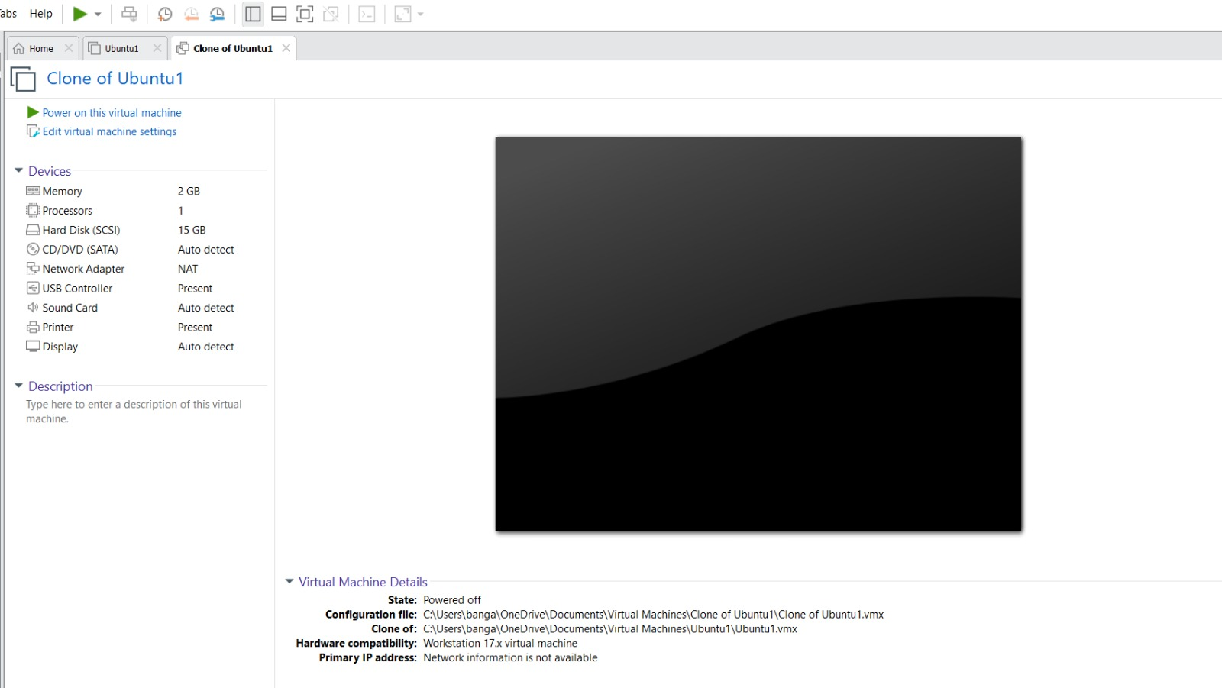
Figure 1: Original Ubuntu1 virtual machine configuration
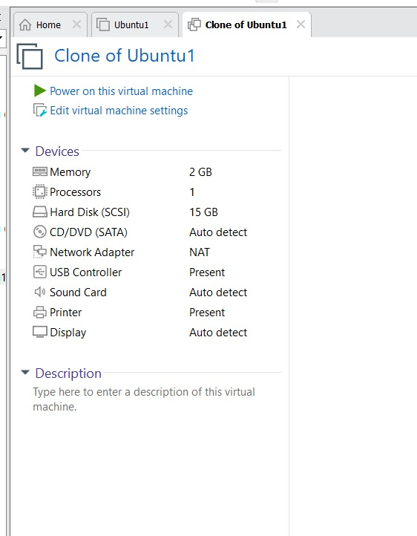
Figure 2: Clone of Ubuntu1 virtual machine

Result
Thus, the Ubuntu1 virtual machine was successfully cloned using VMware Workstation and the cloned VM was loaded and verified successfully.

